John Blythe

Sheffield Hallam University

Laser Projector Guide



Table of Contents

Introduction 2

Health & Safety 4

General Permissions 5

Content & Ethics 5

The Best Types of Surfaces to Project onto 5

Outdoor Projection Request Form 6

# Introduction

The laser projector model is an M-Vision Laser 21000 WUXGA (1920 x 1200), 21.000 Lumens

<https://www.digitalprojection.com/emea/dp-projectors/m-vision-laser-21000-wu/>

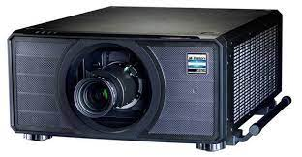

**M-Vision 2100 Laser Projector**

Resolution: 1920 x 1200 pixels native display  
**Aspect Ratio:** 16x10

Weight: 52Kg

Dimensions: L: 74.8cm W: 53.0cm H: 24.8cm

**The laser projector comes in its own Flight Case on wheels**

(This is used to transport the projector and lenses)

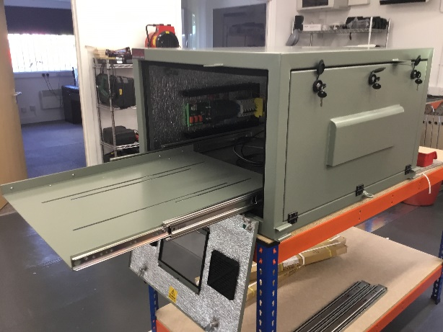

**In addition to the laser projector a weatherproof case is also provided**

(This is used to protect the projector when projecting outside)

Please note: This case weights 90kg

The following lens are included with the projector kit

**120-624: Projector Lens 0,90-1,20:1**

Projection Distance 1.5 m - 10 m (keeping image brightness levels acceptable)

At a distance of 2m throw distance the projection size is 216cm x 135cm

At a distance of 8m throw distance the projection size is 865cm x 540cm

**120-627: Projector Lens 2,00-4,00:1**

Projection Distance: 2.5 m - 15 m (keeping image brightness levels acceptable)

At a 5m throw distance the projection size is 187cm x 117cm

At a 15m throw distance the projection size is 563cm x 352cm

**120-628: Projector Lens 4,00-7,00:1**

Projection Distance: 4 m - 42 m (keeping image brightness levels acceptable)

At a 15m throw distance the projection size is 338cm x 211cm

At a 42m throw distance the projection size is 946cm x 591cm

You can use a **Throw Distance Calculator** to calculate image projection sizes:

<https://www.projectorcentral.com/Digital_Projection-M-Vision_Laser_21000_WU-projection-calculator-pro.htm#calc>

# Health & Safety

There are several health & safety considerations to consider before booking out a laser projector.

Laser classification is subject to national and international standards and has now moved on to ‘laser class’ and ‘risk group’ as descriptions of the hazards associated with this type of illumination.

The hazards considered are actinic ultraviolet, near-UV, retinal blue light, retinal thermal and infra-red eye, with associated limiting exposure times.

**The M-Vision Laser 2100 projector is classified as a Risk Group 3 Projector (Hazardous)**

Operators should control access to the beam within the hazard distance or install the projector at sufficient height to prevent exposures of spectators’ eyes within the hazard distance. Hazard Distance. The hazard distance is the distance measured from the projection lens at which the intensity or energy per unit of surface is lower than the applicable exposure limit on the cornea or skin. If the person is within the hazard distance, the beam is considered unsafe for exposure.

**No direct exposure to the beam is permitted - The hazard distance for the M-Vision Laser 2100 projector is 6.5 m**

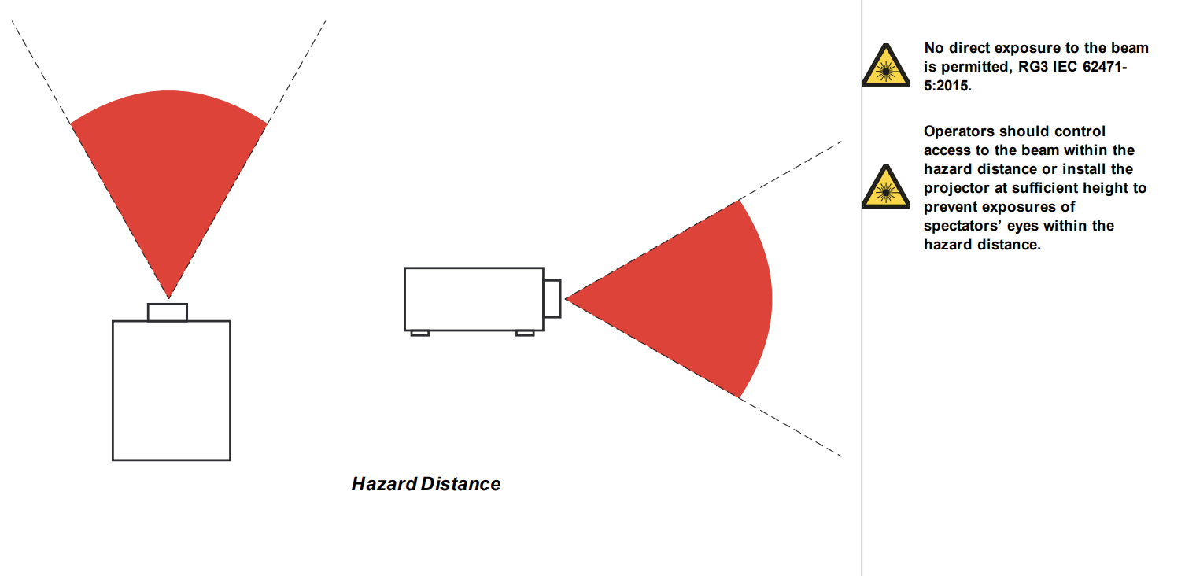

**Important Note: Due to the Hazard distance you will be required to organise a barricade around the projector to create a safe hazard distance of 6.5m and/or place the projector at a height above eye level.**

The projector will require 4 people to lift it out of the flight case (Staff should have completed manual handling training before attempting to lift the projector).

The all-weather case will also require 4 people to lift this into place and should be transported using a suitable platform or transport trolley.

To transport the projector and casing any distance a vehicle with a tail Lift will be required.

**A risk assessment for the any laser projection project will be required once a location and content has been agreed. The risk assessment must take the safe zone and overall weight of the projector into consideration.**

# General Permissions

When projecting outside the owner of the building or structure needs to grant permission first. You may also have to get permission from neighbouring properties if the projection equipment is set up there. For any projection at Sheffield Hallam an ESR must be submitted to inform the estates department of the proposed projection site.

Once the building owner has granted permission, you’ll then need to send an application to the local council to gain their permission.

An application to the council can take anywhere between 6-12 weeks and you will need to provide as much detail as possible including where you are projecting, the size of the projection and the content. Any outdoor projection over 1.2m may also require advertising consent: <https://www.gov.uk/guidance/advertisements>

Please Note: Laser projection could have an unintended, negative effect on the public. eg. Could drivers or cyclists seeing your event's imagery become distracted and cause an accident? Could the lights from the projectors impair the eyesight of those inside or around the building? Please take this into consideration when planning your projection.

# **Content & Ethics**

Before displaying any content, you will need to check if this requires any ethics approval. Projects requiring approval should be submitted for the SHU ethics board for review in advance of any projection.

# The Best Types of Surfaces to Project onto

Some surfaces work better for projection than others. As a general rule of thumb, brighter surfaces are better to work with when it comes to projections as they reflect more light and really bring out the colour from the projector.

# Outdoor Projection Request Form

|  |
| --- |
| **What do you want to project onto and where will you be projecting from?** |
|  |
| **If you are projecting onto a building do you have permission from the owner?**  (If the projection is at SHU please ensure you have completed an ESR Estates form) |
|  |
| **Will the projection be in a public space or viewable by any members of the public?** |
|  |
| **How will you ensure that there is a 6m safe zone around the projector?** |
|  |
| **Is the proposed projection location for the projector easily accessible?** (The location must allow vehicle access and/or allow for a wheeled flight case to be transported to this location) |
|  |
| **Will the projector location have access to electricity?**  (If the projection is at SHU then estates may be able to provide an electrical feed to an external location if one is not available– please request this on the ESR form) |
|  |
| **How will you ensure the projector is kept secure when on location?** |
|  |
| **What kind of content will you be projecting?**  (Does this need to go thru the SHU ethics committee?) |
|  |